Snorkeling Tour Information

Anyone who would like to join the snorkeling tour at Yabiji, a famous snorkeling spot in Miyakojima, must contact us by April 1.

Tour Date & Time
- June 27 – Morning Course (return around 1:00 PM)
- June 27 – Afternoon Course (return around 5:00 PM)
Fee
- 15,000 JPY (includes round-trip bus transportation)

Message from the Snorkeling Tour Guide
This is a boat snorkeling tour to Japan’s largest coral reef, located north of Miyakojima. Once you experience it, many guests are amazed by its beauty and come back again.
This is a luxurious marine activity where you can enjoy snorkeling at three different spots in the Yabiji area. We offer safe and fun snorkeling tours in the waters of Miyakojima. All staff members are professional snorkeling guides, and many of our guides have years of experience.

What to Bring
- Please wear a swimsuit. There is a simple changing room
- Please bring:
  - Towels
  - A change of clothes for after the tour
  - Sunscreen / rash guard (if needed)
  - Motion sickness medicine (if needed)
Equipment Rental (Free of Charge)
Masks, snorkels, life jackets, marine shoes/boots, and fins are available for free rental.
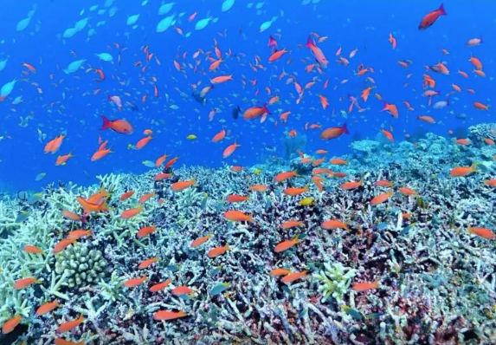
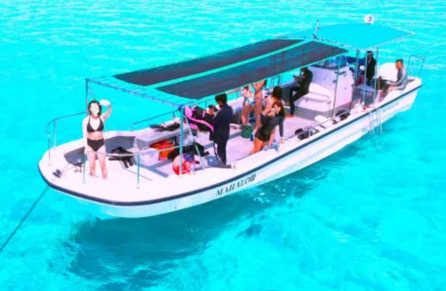

Application Form

If you wish to participate, please email the following information to Kodo Kawase
(Email address: kodo@nagoya-u.jp) by April 1.

Required Information
- Full Name:
- Date of Birth:
- Age (as of June 27): Aged over 65 cannot join this tour.
- Height (cm):
- Weight (kg):
- Gender:
- Shoe Size (cm):
- Eyesight (unaided vision if you wear glasses; vision with contacts if you use contact lenses): 0.1–1.5
- Number of snorkeling or diving experiences (no experience is OK):
- Do you have a diving license? (Yes/No):
- (If yes) Type of license:
- Date of your most recent dive (YYYY/MM/DD):
- Regular medications:
- Prefer the morning course or the afternoon course, or either morning or afternoon is fine

Please send the above to kodo@nagoya-u.jp by April 1.

We will contact you later with details such as the meeting place for the day.

Note: If the number of applicants exceeds capacity, we may have to decline some participants (starting with younger Japanese participants). In that case, we can provide guidance on how to join a snorkeling tour by renting a car and going independently.

